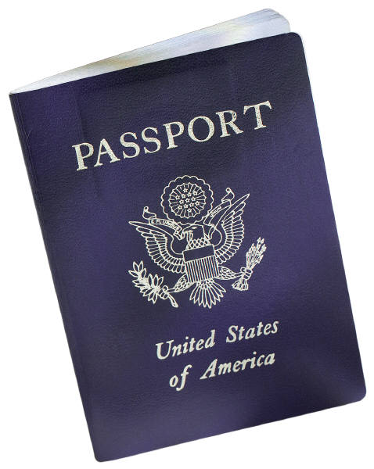

The Get Away Crew

2015 Guidelines

# History

**"The Get Away Crew"**

The inspiration for the Get Away Crew came from Vicki Lake, combining two of her loves traveling and being with family and friends. The basic premise of the “Crew” is to travel every 2 years to a new destination. For the most part, we have been cruising since inception, but we are not limited to traveling via cruise...it just happens to have been the most convenient.

This "Crew" is truly Not for everyone!! Although we are open and free to invite others, we are very selective to whom we extend an invitation. Our inclusion standards: respect, honesty, & caring. Unfortunately, that eliminates 75% of the population :-(. We DO NOT DO drama, backstabbing, meanness, etc. To some, that is a rather high standard to aspire to.....:-/.....WHATEVER, it is simply the basics of preparing to have a Great time with a group. The whole idea of the Get Away Crew is just that...Get Away. To get away from the norm and as with everything, it ALL starts with a State of Mind. Prepare to RELAX, RELAX, BREATH and RELAX some more. Repeat as often as necessary!!

**PLAN TO HAVE A GREAT TIME** and leave worry, stress, tripping, drama, negativity and any other undesired vibes you can think of...leave it all with the people who tried to put that foolishness on you. All the rest is a breeze!

~ Vicki Lake

# Traveling Possibilities

**Past Destinations:**

|  |  |  |
| --- | --- | --- |
| * Alaska * West & East Caribbean * San Juan Puerto Rico * St. Thomas | * Turks & Caicos * Cayman Islands * Half Moon Cay * The Bahamas | * Grand Turk * Cancun * Mexico * Cozumel |

* 2007 Nassau Bahamas 5 night
* 2008 Cozumel Mexico 5 night
* 2009 Carnival Cruise
* 2011 "It's a 20 Year Love Affair" Anniversary cruise (Carnival) of Vicki & Steve
* September 10-17, 2013
* God Did It!! Gave us another Awesome Cruise!
* Alaska truly was amazing!

**Current Destination**

August 30-September 6, 2015 Montego Bay, Jamaica, Grand Cayman, Cozumel, Mexico

**Future Options**

**The World is our Oyster!**

**Please provide your 3 ideas for the next trip.**

**We will vote on the destination at Dinner the last day of the Cruise**

Each time we travel the first day we discuss the available travel options for the next travel period and vote on the travel destination on the last day of the trip. This will provide time for each travel participant to consider the available options and make an informed decision.

# Communication

**Organizer/Coordinator:**

The organizer/coordinator is responsible or supporting Get Away Crew travelers by keeping them informed on the travel itinerary, payment schedules, rates, changes, excursions, travel accommodations etc. The goal is to assist the group in safe fun travels with the Get Away Crew.

The organizer/coordinator will communicate with interested travel participants via communication options:

Pre Travel Communication options:

* Email
* Text
* Website

We are open to other suggestions!!!!

*See Job Description.*

**Travel participants**

Are expected to RESPOND!!!!!!!!!!!!!!!!!!!!!!!! to the communication from the organizer/coordinator(s).

* Walkie Talkies (Two-Way Radios)
  + Each person will have Walkie Talkie.
  + We will coordinate the channel during the embarkation lunch
  + Since cellphones costs are astronomical on the cruise, our means of communication will be Walkie Talkies.
  + We ask that each member of the party carry a walkie talkie so that we can locate members of our parties while on the cruise.

# EXPECTATIONS

**Organizer/Coordinator:**

* Adhere to Job Description to fulfill tasks
* **Select Color & Color day** 
  + We select one day that the entire crew wears the same colors. The 1st time we did it the color was Yellow top with jeans (black or blue). Another trip was Brown top and blue jeans. The person who gets to select color day is generally the coordinator. Sometimes there are multiple coordinators. In the event of multiple coordinators, the responsibilities are shared; color day, gift giving, and information sharing.
* **Gift Giving** 
  + A small token of our appreciation for traveling with us given by an coordinator(s).
* **T-Shirt** 
  + Each time the Get Away Crew travels, we want a T-Shirt that represents the travel event. The T-Shirts will be designed each year to include the Get Away Crew logo along with the travel dates and confirmed travel participants. The T-Shirt will be designed and available for print and delivery to each participant using [www.uberprints.com](http://www.uberprints.com). When the T-Shirt and Design the coordinator/organizer will communicate that the T-shirts are available each participant will log in an order their shirts for delivery to their homes within 30 days of travel. Travelers are responsible or bringing the T-Shirt for the travel dates. Average price will be approximately $25.00 per shirt.
* **Excursion** 
  + In the course of the entire trip, only 1 activity is required as a group - an excursion. The Excursion will be decided based on group voting as of the close of the prior traveling engagement.

**Travel participants**

* Are expected to **READ & RESPOND!!!!!!!!!!!!!!!!!!!!!!!!** to the communication from the organizer/coordinator(s).
* Pay for your travel accommodations
  + You pay the travel vendor
  + Purchase travel T-Shirt
  + You coordinate any
    - Payments
    - Refunds
    - Cancellations
    - Party changes within your room
* **While traveling**
  + **Join the EXHALE PARTY ☺**
  + Provide feedback on next trip
  + VOTE on next trip
  + Participate in at least 1 excursion with group
  + Have Dinner Captains Night and as often as we can
  + Provide testimonials (In Writing!!!!)the last day of your trip and provide them to the organizer/coordinator

# Mission Statement

*Take the opportunity to improve our whole selves!*

* *Time for yourself*
* *Connect with other positive promoting people*
* *Explore God’s handiwork by seeing all that he created during our time here on earth.*
* *GAC*

Life is short Live it

Love it Rare, Grab it

Anger is bad, Dump it

Fear is Awful, Face it

Memories are sweet, Cherish them

# You’RE INvited!!!

**Sharing and Inviting Others**

After each travel event, we have friends and family who are green with envy that they missed the opportunity to travel.

If you are asked about how to join the Get Away Crew please get their email address and send it via email, text, “Carrier Pidgeon☺” to the organizer/coordinator so that we can include them in communications about our travels, deadlines, and costs.

Just Remember the stipulations highlighted by Vicki!!!!!



Traveler Name

Destination :

Destination :

Destination : ­­­­­­­

Length of Travel :

|  |  |  |  |
| --- | --- | --- | --- |
| ⭘ | ⭘ | ⭘ |  |
| 7 Days | 10 Days | 10+ Days |  |

Type of Travel?

|  |  |  |  |
| --- | --- | --- | --- |
| ⭘ | ⭘ | ⭘ |  |
| Cruise | Resort | Rental Home |  |

Type of Excursion?

|  |  |  |  |
| --- | --- | --- | --- |
| ⭘ | ⭘ | ⭘ |  |
| Water | Tour | Air/Flying |  |

Dinner Times?

|  |  |
| --- | --- |
| ⭘ | ⭘ |
| 6pm | 8pm |